**Schallgeschwindigkeit in Luft**

Bei einem Gewitter kann es sein, dass man den Blitz sieht, aber den Donner erst

Sekunden später hört. Wie kann das sein? Findet es heraus….



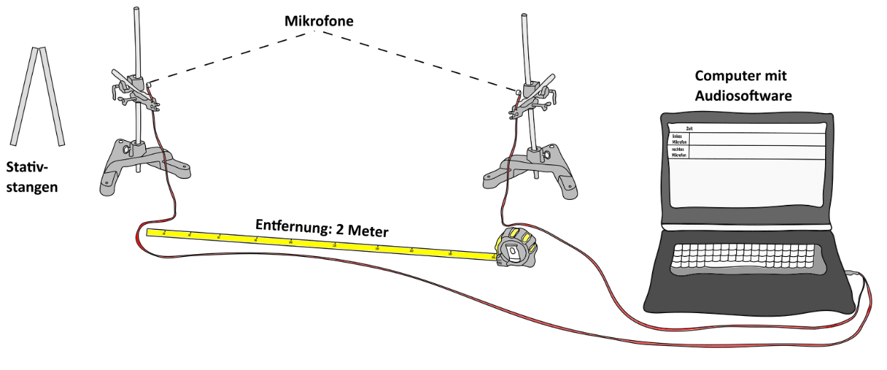



**Formuliere die Durchführung:**

_____________________________________________________________________

_____________________________________________________________________

_____________________________________________________________________

_____________________________________________________________________

_____________________________________________________________________

_____________________________________________________________________

_____________________________________________________________________

_____________________________________________________________________



**Arbeitsauftrag:** Bestimmt für die ausgewählten Audiodateien, die

Schallgeschwindigkeit in Luft! Die Zahlen geben die Zeiten

in Sekunden an.

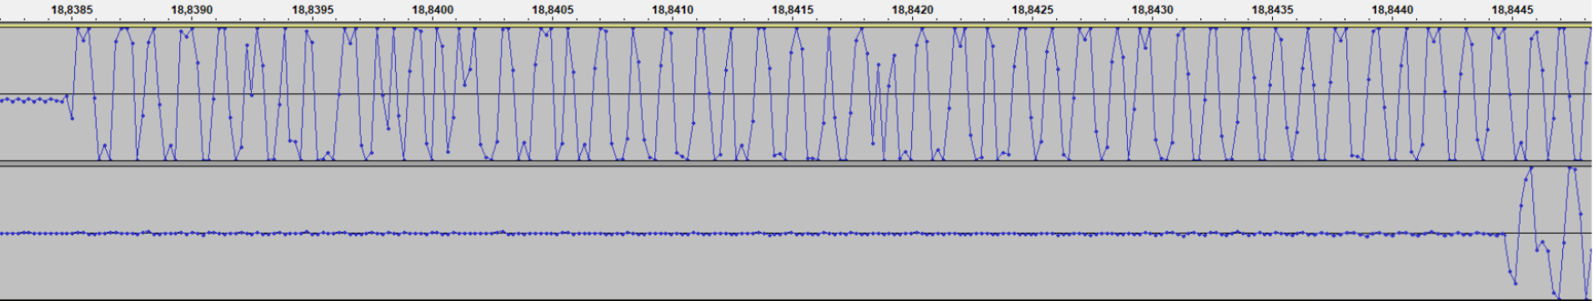

|  |  |  |  |  |  |  |  |  |  |  |  |  |  |  |  |  |  |  |  |  |  |  |  |  |  |  |  |  |  |
| --- | --- | --- | --- | --- | --- | --- | --- | --- | --- | --- | --- | --- | --- | --- | --- | --- | --- | --- | --- | --- | --- | --- | --- | --- | --- | --- | --- | --- | --- |
|  |  |  |  |  |  |  |  |  |  |  |  |  |  |  |  |  |  |  |  |  |  |  |  |  |  |  |  |  |  |
|  |  |  |  |  |  |  |  |  |  |  |  |  |  |  |  |  |  |  |  |  |  |  |  |  |  |  |  |  |  |
|  |  |  |  |  |  |  |  |  |  |  |  |  |  |  |  |  |  |  |  |  |  |  |  |  |  |  |  |  |  |
|  |  |  |  |  |  |  |  |  |  |  |  |  |  |  |  |  |  |  |  |  |  |  |  |  |  |  |  |  |  |

|  |  |  |  |  |  |  |  |  |  |  |  |  |  |  |  |  |  |  |  |  |  |  |  |  |  |  |  |  |  |
| --- | --- | --- | --- | --- | --- | --- | --- | --- | --- | --- | --- | --- | --- | --- | --- | --- | --- | --- | --- | --- | --- | --- | --- | --- | --- | --- | --- | --- | --- |
|  |  |  |  |  |  |  |  |  |  |  |  |  |  |  |  |  |  |  |  |  |  |  |  |  |  |  |  |  |  |
|  |  |  |  |  |  |  |  |  |  |  |  |  |  |  |  |  |  |  |  |  |  |  |  |  |  |  |  |  |  |
|  |  |  |  |  |  |  |  |  |  |  |  |  |  |  |  |  |  |  |  |  |  |  |  |  |  |  |  |  |  |
|  |  |  |  |  |  |  |  |  |  |  |  |  |  |  |  |  |  |  |  |  |  |  |  |  |  |  |  |  |  |

|  |  |  |  |  |  |  |  |  |  |  |  |  |  |  |  |  |  |  |  |  |  |  |  |  |  |  |  |  |  |
| --- | --- | --- | --- | --- | --- | --- | --- | --- | --- | --- | --- | --- | --- | --- | --- | --- | --- | --- | --- | --- | --- | --- | --- | --- | --- | --- | --- | --- | --- |
|  |  |  |  |  |  |  |  |  |  |  |  |  |  |  |  |  |  |  |  |  |  |  |  |  |  |  |  |  |  |
|  |  |  |  |  |  |  |  |  |  |  |  |  |  |  |  |  |  |  |  |  |  |  |  |  |  |  |  |  |  |
|  |  |  |  |  |  |  |  |  |  |  |  |  |  |  |  |  |  |  |  |  |  |  |  |  |  |  |  |  |  |
|  |  |  |  |  |  |  |  |  |  |  |  |  |  |  |  |  |  |  |  |  |  |  |  |  |  |  |  |  |  |
|  |  |  |  |  |  |  |  |  |  |  |  |  |  |  |  |  |  |  |  |  |  |  |  |  |  |  |  |  |  |

Bildet den Mittelwert der drei Werte: _____________________________

